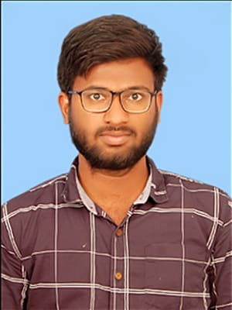THEJA SEKHAR REDDY

GUNDLOORU

+91 9347556116

[gundlooruthejareddy@gmail.com](mailto:gundlooruthejareddy@gmail.com)

Linkedin - https://www.linkedin.com/in/theja-sekhar-reddy-gundlooru-7457821bb

# Career Objective



Looking for a challenging role in a reputable organization to utilize my technical, database, and management skills for the growth of the organization as well as to enhance my knowledge about new and emerging trends in the IT sector.

# Skills

Leadership Skills

Problem Solving

Time Management

Critical Thinking

|  |
| --- |
| **Core Java, C++ STL (Intermediate), Python, SQL, Data Structures, Software Engineering Methodogies, HTML, CSS, JavaScript, Excel, GIT** |

**Languages**

**/ Software**

# Projects

Web Application on Sports Meet – Nov 2021 to Jan 2022

web based Application which provides interface between college students and college physical department.

Linear Data Structure Visualizer – Feb 2022 to May 2022

This project is to visualize linear data structures execution procedure developed in python using Tkinter Module.

Smart Event Organizer – Jan 2023 to Mar 2023

This project is developed for the college events organizing, this project is underutilization by the college management.

# Education

2019 - ongoing

Rajeev Gandhi Memorial College of Engineering and Technology, Kurnool, A.P

Bachelor of Engineering (CSE)

8.4/10 CGPA Upto 4-1 Sem

2017 - 2019 Narayana Junior

College, Tirupathi, A.P

2016 – 2017 V.S.N Siddhartha High School, Piler,

A.P

HSC

9.8/10 CGPA

SSC

9.2/10 CGPA

|  |
| --- |
| 1. Programming Essentials in python by CISCO2. Networking Essentials by CISCO3. AWS Academy Cloud Foundations4. AWS certified Developer-Associate5. Git certification by Simplilearn |

# Certifications

# Hobbies

# 

# Personal Details

* Puzzle Solving
* Playing Cricket
* Drawing
* Listening Music

Father’s Name : G. Swathanthra Reddy Mother’s Name : G. Vijaya Kumari

Date of Birth : 25 Aug 2001 Gender : Male

Languages : English, Telugu

Address : 1-12/1, Sadum, Chittor, A.P

I hereby declare that all the above mentioned details are true to the best of my knowledge.

**Declaration**